CYBAEM TECH
Home Page :
- Double Comma / Incorrect Punctuation Issue
Description: There is an unnecessary double punctuation/quotation formatting issue in the text:
- “The ”Zero Scope-Creep” Architecture”
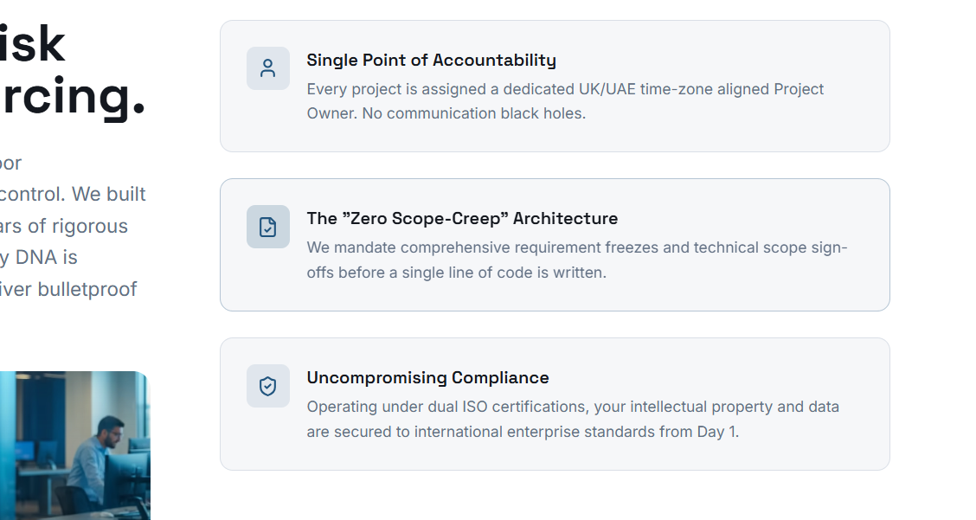

- Content/Text Overlapping on Mobile View
Description: On mobile screen resolution, the region label (“United States”) overlaps with the paragraph text in the “Strategic Growth Regions 2025–2027” section. This causes poor readability and affects the UI appearance.


- Content/Text Overlapping
Description: The quotation marks appear inconsistent and visually incorrect, which affects readability and professional UI presentation.


Page is Responsive

Our Solution : Page-1 Enterprise software
- Hero Section Text Cropped / Partially Hidden on Desktop Resolution
Description: The heading text in the hero/banner section is partially cut off from the top on certain desktop screen resolutions and display scaling settings.
Although the text appears correctly on some systems, users with different screen sizes, browser zoom levels, or Windows display scaling (125%, 150%, etc.) may experience cropped text visibility.
The upper portion of the heading is not fully visible, reducing readability and affecting the overall UI presentation.

- Non-Clickable Video Preview and Product Details Button
Description: The “Hover to Preview” video section and “Product Details” button are displayed as plain text/UI elements but are not clickable or interactive.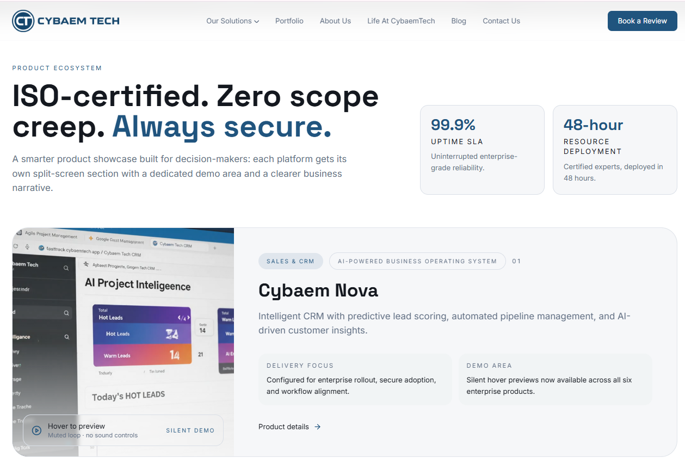

- Double Comma / Incorrect Punctuation Issue
Description: There is an unnecessary double punctuation/quotation formatting issue in the text
- The ”Zero Security incidents…….”

Page is Responsive

Our Solution : Page-2 Web Designing
- Text Overlapping and UI Alignment Issue
Description: The emoji/icon and small heading text are displayed too close together or on top of each other. Due to improper spacing, padding, or responsive alignment, the content overlaps and appears broken on the screen.



Our Solution : Page-3 IT Augmentation
- Text and Background Overlapping Issue
Description: The “Collab” text/content appears improperly aligned with the background design, causing a visual overlap and reducing readability.

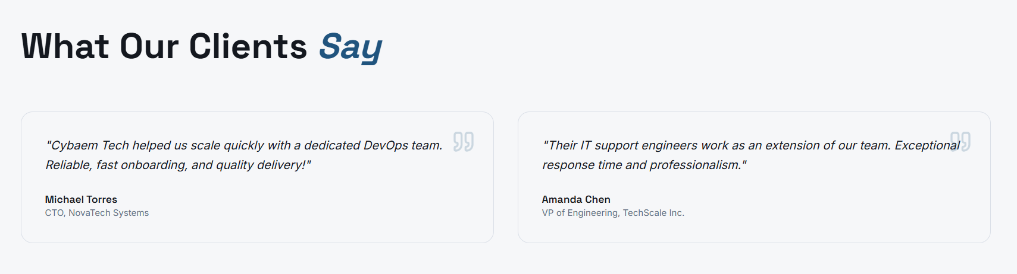

Page is Responsive
Our Solution : Page-4 Cloud & Security
Our Solution : Page-5 Growth & Revenue
- Content/Text Overlapping on Mobile View
Description: On mobile screen resolution, the region label (“CRM”) overlaps with the paragraph text in the “How Cybaem Tech Solves it” section. This causes poor readability and affects the UI appearance.
- Inconsistent spacing
Description: Some sections have uneven spacing and alignment issues, especially card sections and metrics areas.
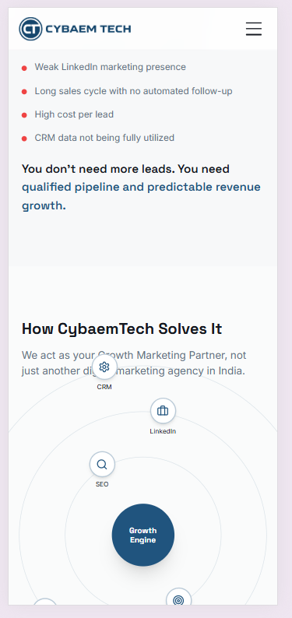

- Double Comma / Incorrect Punctuation Issue
Description: There is an unnecessary double punctuation/quotation formatting issue in the text

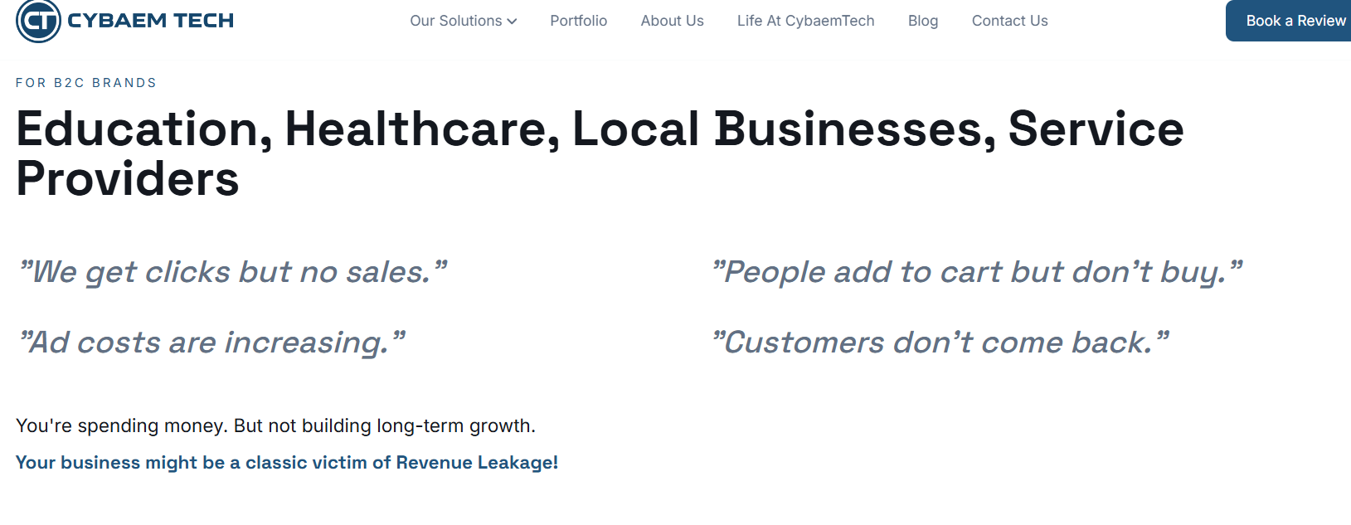

Page is Responsive

Portfolio -Done
About us -Done
Life at CybaemTech – Done

Blog
- Blog Section they Email field accepts invalid email format
Description: The email input field accepts incorrect email formats without showing any validation error. The form should validate the email structure before submission.

- Abc@34Gmail.com
- test@com
- 2@gmail.com
- vaibhaviaher0@gmailcom


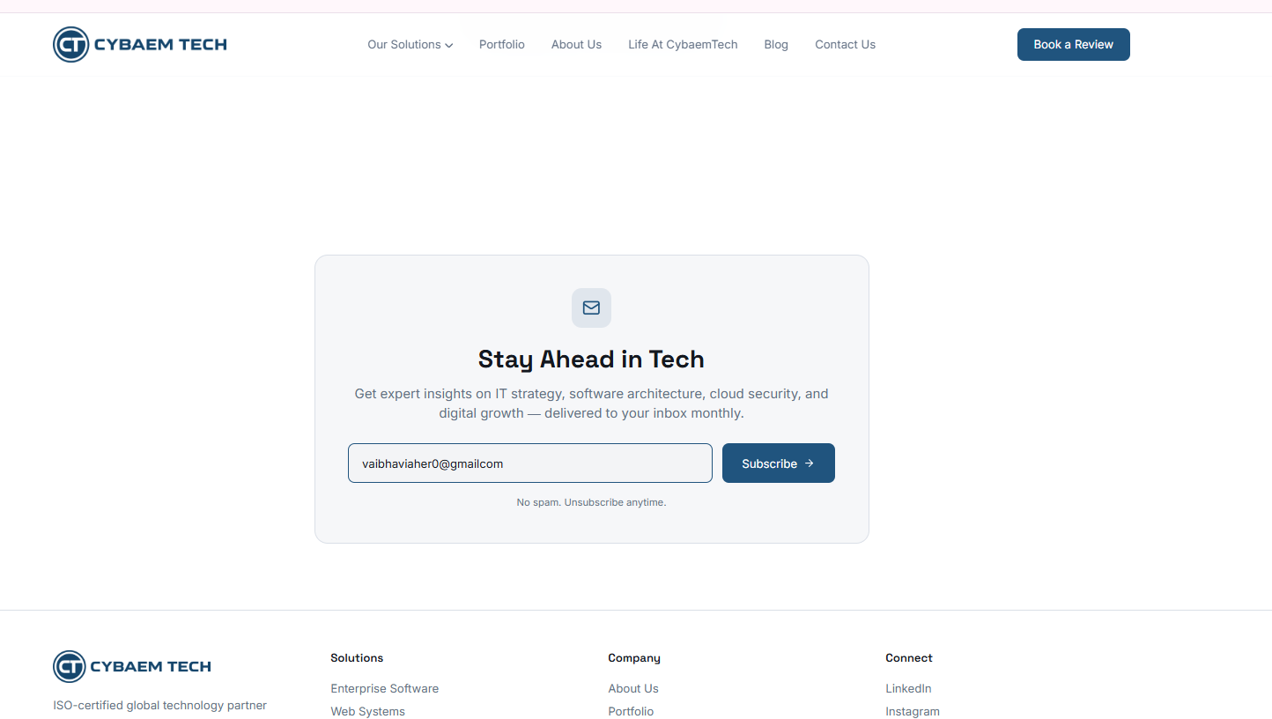


Contact us
- Full Name field accepts numbers and special characters
Description : The “Full Name” input field accepts invalid characters such as numbers and special symbols (@, digits). A name field should only allow alphabetical characters and limited special characters like spaces.

